

Job Description - Sessional Early Years Assistant

Riverside Community Health Project (Riverside)
Riverside works to improve the health and well-being of disadvantaged communities within the west end of Newcastle.

Job Purpose
To deliver and develop activities and services for young children and their carers within the Carnegie Building and at other venues. The following list of key tasks is not exhaustive:

Key Tasks

- Support the team to plan and deliver a range of play sessions.
- Monitor and evaluate activities for young children and their carers
- Signpost parents to services as appropriate.
- Advise children and family colleagues of any concerns regarding children, parents, and safety of the environment.
- Be flexible within working practices and duties where needed such as domestic tasks, preparing snacks and cleaning equipment.
- To attend meetings, one to one supervision and training as required.
- To follow organisational policies, including but not limited to Equality and Diversity, Health and Safety, and Creche Policies. To report any concerns about these matters in line with organisational procedures.

Commitment to equal opportunities
All employees are expected to work in ways that further Riverside’s commitment to equal opportunities and anti-discriminatory practice.
.

Hours
The hours of this post are sessional by negotiation between the post-holder and Riverside.

Person Specification
Sessional Early Years Assistant

 | Requirements | Measurements
Knowledge | Knowledge of child development, children’s needs and systems relevant to early years, such as EYFS and SEN | Interview
Skills | Ability to communicate well and develop positive relationships with adults and children | Interview
 | Ability to work as part of a team | Interview
 | Ability to use of Microsoft Office and email | Application form
Values | Commitment to equal opportunities | Interview
Experience | Previous experience of working with children | Application form  Interview
Special Requirements | The work involves bending, kneeling and crouching for periods of time and may also involve lifting or holding children. Therefore, the ability and willingness to undertake these tasks are essential. | Application form  Interview
 | Minimum Level 2 relevant and recognised qualification in child care – Level 3 desirable. | Certificates
 | Ability to pass relevant DBS Checks | Disclosure  DBS Results
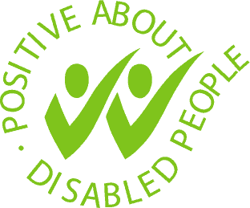
Riverside Community Health Project, Carnegie Building,
Atkinson Road, Benwell, Newcastle upon Tyne NE4 8XS
T: 0191 2260754 E: all@riversidechp.co.uk W: www.riversidechp.co.uk
Charity Number: 1028632 Company Number: 02869470

