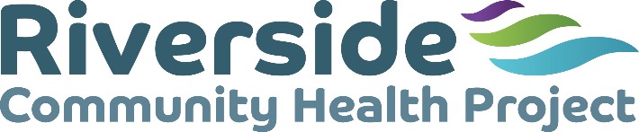

Job Description - Sessional Receptionist

Riverside Community Health Project (Riverside) works to improve the health and well-being of disadvantaged communities within the west end of Newcastle.

Job Purpose

To provide frontline reception duties in Carnegie Building, a vibrant Community Hub operated by Riverside and which hosts various community services and organisations. To provide associated administrative tasks for Riverside. The following list of typical duties is not exhaustive:

Duties

- To welcome diverse visitors to Carnegie Building and direct them to the appropriate person, service or organisation in the building
- To deal with telephone enquiries and forward calls to the relevant person or service
- To keep updated on the groups and activities taking place in Carnegie Building to provide community members with information relevant to their enquiry
- To input confidential data about Riverside’s work into database systems operated by the organisation.
- To carry out administration tasks relevant to the reception, such as photocopying, scanning and distributing information, completing the weekly programme on the white board.
- To follow organisational policies and procedures, including but not limited to Equality and Diversity, Health and Safety, and Information Governance and report any concerns about these matters in line with the procedures
- To attend meetings, line management supervision and training as required.
- To follow organisational policies, including but not limited to Equality and Diversity, Health and Safety, Safeguarding and Leave Policies. To report any concerns about these matters in line with organisational procedures.

Commitment to equal opportunities
All employees are expected to work to further Riverside’s commitment to equal opportunities and anti-discriminatory practice.

Hours
The hours of this post are sessional by negotiation between the post-holder and Riverside.
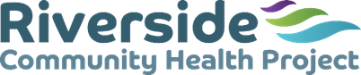

Person Specification
Sessional Receptionist

 | Requirements | Measurements
Skills | Ability to communicate well | Interview
 | Ability to work as part of a team | Interview
 | IT skills, with proficient use of Microsoft Office and email, as a minimum | Application form  Interview task
 | Ability to learn to use office machinery including photocopier and, telephone systems | Interview
 | Ability to prioritise tasks | Interview task
Values | Commitment to equal opportunities | Interview
Experience | Previous experience of reception work, customer service (or equivalent) | Application form  Interview
 | Ability to pass relevant DBS Checks | Disclosure  DBS Results



Riverside Community Health Project, Carnegie Building,
Atkinson Road, Benwell, Newcastle upon Tyne NE4 8XS
T: 0191 2260754 E: all@riversidechp.co.uk W: www.riversidechp.co.uk
Charity Number: 1028632 Company Number: 02869470

